Accident or Negligence?
The death of Nigel Aylott on Illabot Peak
2004 Subaru Primal Quest
Safety and Adventure Racing

On September 4, 2010, Michael Aylott and I climbed Illabot Peak to place a plaque to honor his brother Nigel Aylott. Nigel, as many will recall, was tragically killed while he and his team, AROC, were leading the 2004 Subaru Primal Quest Adventure Race in Washington State. Nigel’s team was climbing down a treacherous gully just below Illabot Peak on the third day of the race when a large bolder was dislodged by the following team and narrowly missed the others before fatally striking Nigel. At the time AROC, together with Team Montrail, was over four hours in front of 3rd placed Team Nike and six hours in front of Team Seagate. The weather conditions were fine and it was mid afternoon with good visibility.

I was a member of AROC’s crew, and waited that day at the transition area in Rockport, expecting their return before dark. The devastating news came around 4pm. Nigel was dead. The entire race was stopped as teams gathered at the TA and mourned.

Explanations were contemplated. Whispers of blame swirled. “AROC hadn’t got enough sleep.” “They were too aggressive.” Even Dan Barger, the race director, said “they didn’t HAVE to go down that way.” People naturally assumed that the accident resulted because the two teams were pushing too hard and didn't take precautions, they were in the wrong area, or they chose the wrong route. The facts tell a different story:

- The area of Illabot Peak had sheer cliffs and large scrappy and loose rocks which needed to be negotiated to get to and from the checkpoint. There were no fixed ropes, no safety staff and no instructions.
- The two teams were meant to be exactly where they were. The checkpoint marker, which was compulsory to go to, was less than 15 feet from the boulder that was dislodged.
- Helmets were not part of the required gear for the leg. It was called an orienteering leg and the only instruction was that teams had to go to the checkpoints in alphabetical order.
- The 'orienteering map' for this leg was a low-resolution color photocopy. The contours and features were not clear on the map.
- Team AROC had indeed stopped for two sleeps during the race but they did this out on the course, rather than at a transition. This was exactly to their practiced plan and the team were all feeling well and moving fine.

In the end, it was generally presumed that Nigel’s death was the result of a terrible accident. No one thought that the blame was the course itself, except for the eight who were there.
The coroner classified his death as an accident. For all these years, I too, assumed it was no one’s fault, just a random tragedy.

Tom Landon-Smith, navigator for Team AROC, didn’t think it was an accident. I can remember Tom quite bitterly questioning the lack of an investigation. Tom thought the checkpoint on top of Illabot was a certain death trap and that an incident would have undoubtedly happened to one of the leading teams. I remember him saying, “I felt sorry for Dan, because I thought he was going to jail.” Usually easy going and affable, Tom’s lingering bitterness about the resolution of the whole matter was a side of him I had never seen. Frankly, I thought Tom was either reacting to the subtle aspersions of fault cast his way or maybe he just needed ‘something’ to blame. I also recall Alina McMaster, AROC team captain and Tom’s wife, describing to me the steep slopes and unstable, rotten rock as they began their descent and saying, “We were scared.” It was hard for me to imagine this fearless duo being afraid. Although I didn’t understand, I tried to empathize.

Over five years had passed and Michael decided he would like to go to Illabot Peak and place a plaque to honor his brother. I offered to help. We started to research various sources to determine the best way to ascend Illabot Peak, a luxury not available to teams during the race. We scoured mountaineering websites and forums like Peakbagger and Summitpost, studied topo maps, and consulted with the rangers at the Forest Service. I was alarmed at the cautionary vibe of the comments on the forums made by climbers, not hikers. Helmets and ropes were strongly recommended. There were warnings of loose rocks, unstable scree, cliffs, and “lurking class 5 moves.” Rain was said to make the terrain slippery and dangerous.

The route we chose started at an unmaintained trail at the end of FS Road 1610, SW of the Peak at about 4100ft. We hiked past Lake Tupso and then on to the ridge above Lake Louise where the trail ended. From there we traversed NE across a steep boulder field to the saddle that had contained CP C. We then descended down to the Bluebell Basin and preceded to bushwhack to the NW, up a very steep slope of slippery heather, which surely would have been near impossible to ascend had it been raining. We gained the SW ridge and began our ascent up the Peak, following a route described in detail on the web. It was very steep going, crawling and grasping onto tree limbs to make our way. About 300 meters from the top we came to a spot where, had we not known which route to choose, trouble lurked. Around to the left or west, we would have encountered narrow ledges with sheer drops and impassable cliffs. Straight and we would have needed to use our ropes and better climbing skills than we possessed. We followed instructions and traversed to the NE along the base of a steep cliff. We then came to a tricky bulging rock with a precipitous drop below. We hugged the rock, searching for handholds, felt blindly for footholds, and finally pulled ourselves up via a gnarly old snag into a gully stuffed with small cedar scrubs. The gully was very steep with lots of loose rock and no way to see if the route would work. I scrambled first while Michael waited as rocks tumbled by. I emerged from the scrubs after about 50 feet and had one last tricky move to the right to reach the summit. Michael followed.

At the summit, on the flat portion of a rock facing Mt. Baker, we installed a plaque. Here is a photo.

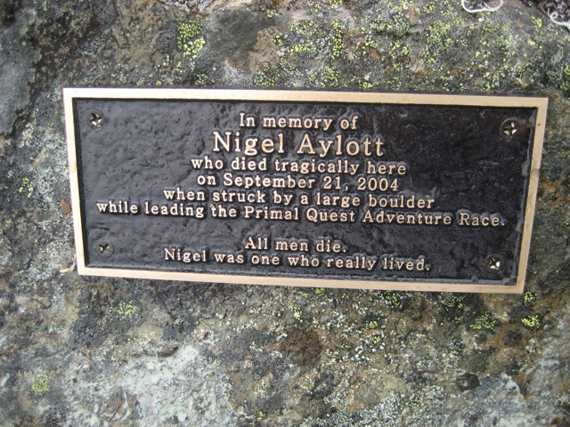

The best way down from the peak is not clear. It appears extremely dodgy any way you look. The climbing websites describe rappels. As many have experienced, it is frequently more difficult to descend these types of craggy peaks than to ascend them. Michael and I carefully crawled backwards down the gully of scrubs to the bulging rock. With heart rate elevated from the surging adrenalin, I made the last difficult move to solid footing and then guided Michael’s foot placements.

Rather than head down into the basin and back up to the saddle where the next CP was located, we tried to follow the SW ridge down and then traverse around to the saddle to not loose elevation, as some teams might have done. However, we were blocked by a number of sheer drops that were difficult to spot even in daylight. In the dark of night, we might not have seen them.

While trekking back down the trail to our car, I asked Michael how he felt. He was relieved the task was complete and the danger was past. But as for the rest, his reaction was mixed. He was glad to finally see the place where his brother died and to honor him. But, he was also bitterly sad to discover his death was unnecessary. “The race shouldn’t have gone there,” he said. ”If it hadn’t been AROC, it would have been another team.” Michael was right. And so too was Tom Landon-Smith and Rebecca Rusch, captain of Team Montrail, the other team on the Peak that day. The course shouldn’t have had a checkpoint on the top of Illabot Peak. Adventure Racing is not meant to be a dangerous sport. Safety should be paramount. At the very least, helmets should have been mandatory gear for this leg. Ropes should have been set as handholds and guidance. But even with these precautions, the Peak would have been dangerous in poor weather conditions and absolutely treacherous at night. With multiple teams ascending and descending at the same time, all choosing various routes, an incident involving loose rock was a given. AROC and Montrail were amongst the most accomplished adventure racers on the planet. Consider the inevitable mayhem that would have occurred when the less experienced teams arrived, in the dark!

I have written this story now, over six years after Nigel Aylott was killed because of my recent realization and shock at just how dangerous Mt Illabot was, my sorrow for Nigel for needlessly losing his life, and for his team and family for their suffering. I was the team’s support crew and got their first hand account of the situation, but even I couldn’t understand or appreciate. But now I know, six years on that it was impossible to understand unless you climbed Mt Illabot. No-one else understood because no other teams ever made it anywhere near Mt Illabot. It was a disaster waiting to happen and it was so plainly obvious. So how did it happen that this was part of the course? Did Race Director Dan Barger and his team actually climb and descend Illabot Peak? Or did they just place the CP via helicopter? Was this part of the course properly vetted or not? Was there criminal negligence? These are questions that were never investigated or even considered. Perhaps they should have been.

DJ Brooks
November 2010

